**A PROJECT REPORT ON**

**IOT BASED SMART WASTE MANAGEMENT SYSTEM**

**Submitted to**

# JAWAHARLAL NEHRU TECHNOLOGICAL UNIVERSITY KAKINADA

**In Partial Fulfilment for The Award of the Degree of**

**BACHELOR OF TECHNOLOGY**

**In**

**ELECTRONICS & COMMUNICATION ENGINEERING**

**Submitted by**

|  |  |
| --- | --- |
|  |  |
| **Mr. K. MURALI MANOHARA JOSHI**  **Ms. K. VENNELA** | **218X1A0422**  **218X1A0434** |
| **Ms. K. UDAYA SRI**  **Mr. K. AVINASH** | **218X1A0442**  **218X1A0432** |
|  |  |
|  |  |
|  |  |

**Under the Esteemed Guidance of**

## Mr. T. RAVIKANTH (M.Tech), Associate Professor



DEPARTMENT OF ELECTRONICS & COMMUNICATION ENGINEERING

**KALLAM HARANADHAREDDY INSTITUTE OF TECHNOLOGY**

**(AUTONOMOUS)**

Approved by AICTE- New Delhi, Accredited by NAAC with an ‘A’ Grade

Permanently Affiliated to JNTUK, Kakinada NH-5,

Chowdavaram, Guntur

2021-2025

**KALLAM HARANADHAREDDY INSTITUTE OF TECHNOLOGY**

**(AUTONOMOUS)**

**DEPARTMENT OF ELECTRONICS & COMMUNICATION ENGINEERING**



## CERTIFICATE

This is to certify that the Project report entitled “**IOT BASED SMART WASTE MANAGEMENT SYSTEM”** is submitted by **K.MURALI MANOHARA JOSHI(218X1A0422), K.VENNELA(218X1A0434), K.UDAYA SRI (218X1A0442), K.AVINASH (218XA0432),** to the Jawaharlal Nehru Technological University Kakinada in partial fulfilment for the award of degree of Bachelor of Technology in Electronics and Communication Engineering is a Bonafide record of the Project work carried out by them under my supervision during the academic year 2024-2025.

|  |  |
| --- | --- |
| **PROJECT GUIDE** | **HEAD OF THE DEPARTMENT** |
| Mr. T. RAVIKANTH (M.Tech) | Dr. S.SURYANARAYANA, M.Tech, Ph.D |
| Associate Professor | Professor & HOD |

**External Examiner**

**DECLARATION**

We KALVA MURALI MANOHARA JOSHI (218X1A0422), KOMMURI VENNELA (218X1A0434), KUSAM UDAYA SRI (218X1A0442), KOLANIDI AVINASH (218X1A0432), here by declare that the entire project work embodied in this dissertation titled “SMART WASTE MANAGEMENT SYSTEM” under the guidance of Mr. T.RAVIKANTH, (M.Tech) Associate Professor is submitted in partial fulfilment of the requirements for the award of the degree of bachelor of technology in Electronics and Communication Engineering. As per my knowledge, no part of this work has submitted for any degree in any institution, university and organization previously.

**BATCH:07**

KALVA MURALI MANOHARA JOSHI 218X1A0422

KOMMURI VENNELA 218X1A0434

KUSAM UDAYA SRI 218X1A0442

KOLANIDI AVINASH 218X1A0432

**ACKNOWLEDGEMENTS**

We proudly express our gratitude and respect towards our honorable Chairman **Sri KALLAM MOHAN REDDY**, Chairman of Kallam group for his precious support in the college.

We are thankful to **Dr. M. UMA SANKARA REDDY**, Director for his encouragement and support for the completion of project we are inspired a lot through his valuable message.

We express our great pleasure to **Dr. B. S. B. Reddy,** Principal, KHIT, Guntur, for his Support during and till the completion of the project.

We are really thankful to **Dr. S. SURYANARAYANA,** Professor and Head of the Department of **Electronics And Communication Engineering,** for providing the laboratory facilities to the fullest extent as and when required and also for giving us the opportunity to carry out the project work in the college.

We are really thankful to our project guide **Mr. T. RAVIKANTH, Associate Professor,** KHIT, Guntur, for his excellent guidance right from selection of the project and his valuable suggestions throughout the project work.

We are thankful to all teaching and non-teaching of Electronics and Communication Engineering department and management my friends for their direct and indirect support provided to us in completing the project work.

KALVA MURALI MANOHARA JOSHI 218X1A0422

KOMMURI VENNELA 218X1A0434

KUSAM UDAYA SRI 218X1A0442

KOLANIDI AVINASH 218X1A0432

Place: Guntur

Date:

|  |  |
| --- | --- |
|  |  |

**TABLE OF CONTENTS**

**ACKNOWLEDGEMENT ABSTRACT**

**LIST OF FIGURES**

**LIST OF ABBREVATIONS**

**CHAPTER**- **1:**

* 1. Prologue 1
  2. Waste Management 2
  3. Internet of Things 6

**CHAPTER**- **2:**

* 1. Block Diagram of Smart Waste Management System 9
  2. Prototype of Smart Waste Management System 10
  3. Working Principle 12
  4. Circuit Diagram 13
  5. Implementation of Smart Waste Management System 15

CHAPTER- 3:

* 1. Arduino IDE 16
  2. Installing Arduino IDE 17

CHAPTER-4:

* 1. Components Required 23
  2. Arduino UNO 23
     1. Communication 26
     2. Specifications of Arduino Uno 27
  3. Sensors
     1. Inductive Proximity Sensor 28
     2. Proximity Sensor 30
     3. Moisture Sensor 33
     4. IR Sensor 35
  4. Lead Acid Battery 39
  5. Servo Motor 40

CODE OF THE PROJECT

CONCLUSION 42

REFERENCES 43

**LIST OF FIGURES**

Fig 1.1 Block diagram of Internet of Things

Fig 2.1 Methodology of Waste Management Fig 2.2 Waste Management System

Fig 2.3 Controlling of Servo Motor Fig 2.4 Circuit Diagram

Fig 2.5 Implementation of Smart Waste Management System Fig 3.1 Arduino Installation

Fig 3.2 Arduino Setup

Fig 3.3 Arduino software installation Fig 4.1 Arduino

Fig 4.2 Inductive Proximity Sensor

Fig 4.3 Working of Inductive Proximity Sensor Fig 4.4 Proximity Sensor

Fig 4.5 Working of Inductive Proximity Sensor Fig 4.6 Moisture Sensor

Fig 4.7 IR Sensor

Fig 4.8 Working of IR Sensor Fig 4.9 Lead Acid Battery Fig 4.10 Servo Motor

Fig 4.11 Servo Motor Pin Description

## LIST OF ABBREVATIONS

1. **IOT :** Internet Of Things
2. **UI :** User Interface
3. **SWM :** Smart Waste Management
4. **UID :** Unique Identifiers
5. **ASIC :** Application Specific Integrated Circuits
6. **GPU :** Graphics Processing Unit
7. **DSP :** Digital Signal Processors
8. **GPS :** Global Positioning System
9. **PWM :** Pulse Width Modulation
10. **SPI :** Serial Peripheral Interface
11. **UART :** Universal Asynchronous Receiver Transmitter
12. **I2C :** Inter Integrated Circuit
13. **MSW :** Municipal Solid Waste

**Abstract**

In many places, it can be seen that the Municipal garbage bins are overflowing and they are not cleaned at proper time. As a result of which the consequences are severe. It includes overflow of garbage which results land pollution, spread of diseases. It also creates unhygienic conditions for people, and ugliness to that place.

There should be a system that can monitor the bin and can give the information of filling of the bin to the municipality using wireless sensor network so that the bin can be cleaned on time and the environment can be safeguarded. The Smart Waste Management System that identifiers fullness of the bin using a wireless sensor network (WSN). The system provides a web interface to the cleaning authority so that they can monitor and clean the garbage bin.

In this ultra-sonic sensors are used to determine the status of the dust bins. The status is read by Node-Mcu and transmitted to the cloud server (THING SPEAK). The server controlled in the municipality office will read this data and determine which dust bin is to be emptied or full and timely inform to driver to collect waste.

Keywords: Municipak garbage bin, Ultrasonic sensor, NodeMCU, ThingSPEAK, Monitoring

**CHAPTER 1**

# PROLOGUE

### Introduction

Garbage is an important issue that needs to be handled wisely. We separate household waste for easy disposal and recycling. We've seen garbage trucks come to homes badly and cause chaos in families.

This is why many citizens are packing too many containers in the open. This increases environmental pollution. Waste is a problem and we cannot ignore it. Garbage is the home of all insects that cause food poisoning and many other diseases.

Waste control refers to the techniques, strategies and technologies used to manipulate the collection, transportation, disposal and recycling of waste.

Waste control is designed to make sure that waste is disposed of in a safe and environmentally sound manner while promoting the conservation of assets and decreasing the poor impact of waste on public health, cleanliness and the environment.

A typical waste management system includes many components, including waste collection, transportation, treatment and disposal. Garbage collection involves collecting waste from homes, businesses and other places and transporting it to waste treatment plants. Waste transportation involves transporting waste from collection points to treatment plants, usually using specialized trucks and equipment.

Waste treatment involves sorting, sorting and treating waste to facilitate recycling, composting or disposal. Recycling involves turning waste into new products, while composting breaks down organic waste into valuable nutrients that can be used as fertilizer. Waste disposal usually involves burial in landfills or power plants that convert waste materials into energy.

Typical, a nicely-designed waste control gadget can help reduce pollution, preserve natural resources and help sustainable development. proper waste control requires the cooperation of individuals, agencies and government businesses at all stages to ensure that waste is disposed of in an green and environmentally sound manner.

### Waste Management

Waste control answers encompass smart sensors that use ultrasonic era to measure fill levels in and out of packing containers. They send data to the clever Waste control device, a powerful cloud-based platform, thru diverse IoT communications.

The aim is to provide cities and businesses with data-driven decision making and waste collection optimization. Monitoring and finding the appropriate process is an important issue, some processes, such as the government, should establish strict rules to prevent people from littering against businesses that do not use Biodegradable materials, use recycled materials, reduce bad products, reuse the product, such use will reduce waste to some extent.

Along with this, the idea of using technology is introduced to dispose of garbage correctly and reduce its damage. Everyone wants to visit a new and clean city. A stinking city full of garbage does not attract tourists, does not waste money and time.

For the reason that we're a developing united states, waste control may be very critical and like a rustic with a huge populace, we need to govern and control the whole thing effectively. stable waste management (SWM) is a primary undertaking going through many city municipalities (ULB) in India, where urbanization, industrialization and economic growth are leading to an boom in municipal stable waste (MSW) in line with capita. effective SWM is a chief challenge for towns with high populace density. reaching sustainable improvement in a rustic with a unexpectedly growing populace and rising dwelling standards is greater difficult in India as it's miles a various country with many faiths, cultures and traditions.

The casual zone plays an vital function in reaping the value of waste, and presently round 90% of waste is thrown away as opposed to well disposed of. there may be an urgent need to transition to a extra sustainable SWM, which requires new management structures and waste control facilities.

The contemporary SWM gadget is ineffective and wastes negatively affect public health, the environment and the economy. Waste management in India is managed by using the Ministry of surroundings and Forestry (MoEF), however exercise is variable and limited.

A developing country like India can support smart technologies that will help our country in the future. Therefore, smart waste management systems have the best development potential in our country, where sanitation is an important issue. We implemented a small-scale waste management model using IoT technology, which is briefly described below.

Waste separation refers back to the separation of waste into dry waste and moist waste. Dry waste consists of timber and other substances, metal and glass. moist waste typically refers to waste produced through cooking centers this is heavy due to moisture.

Waste sorting isn't the same as waste sorting. Waste separation is the separation of wastes into special categories. each type of waste is placed in its very own category whilst dumped or gathered, however identity takes vicinity after dumping or series. Waste evaluation ensures that the information is clean and good. on the other hand, analysis creates an impure made from poor quality.

**Wet Waste**

Wet waste refers to food, contaminated food, hygiene products, garden waste, all organic materials such as wipes and paper towels, and other products. Dirt that can be recycled. Used for wet waste composting. it's far vital to split wet and dry waste because dry waste need to be freed from contamination for recycling.

Wet waste, also known as organic waste, is biodegradable waste that contains organic compounds such as food waste, garden waste, and animal waste. Such waste usually has a high moisture content and is easy to decompose. moist waste is frequently separated from other types of waste along with plastic and paper and can be used for composting or shredding to supply biogas and compost. Proper management of wet waste is important to reduce carbon monoxide emissions and conserve natural resources.

### Dry Waste

Dry waste contains paper, glass, plastic, cardboard, rubber, metallic, food packaging cloth, and many others. Even milk cartons and packets pass right into a dry waste bin. Dry waste is recyclable however could be rejected if it's far infected or dirty. In dry there have been many cloth that may be recycled and reuse a number of them are paper and steel.

Dry waste refers to non-biodegradable waste that does not decompose easily, such as plastic, metal, glass, and paper. Unlike wet waste, dry waste does not contain organic compounds and has a low moisture content. Dry waste is usually recycled and can be processed into new products such as paper or plastic. However, if not managed properly, dry waste can have adverse environmental impacts, including pollution and resource use. Therefore, it is important to separate dry waste from wet waste for easy recycling and proper disposal.

### Metal Waste

Scrap metal refers to scrap metal products and materials that are no longer useful or desirable. This includes materials such as steel, aluminum, copper, brass and copper. Metal waste comes from many sources, together with groups, production websites and families. Recycling steel waste is vital because it enables preserve natural sources and decrease waste despatched to landfills. steel recycling includes sorting and separating exclusive varieties of metals, casting off impurities and melting them to make new merchandise.

Non-metal waste, paper, plastic, glass, textile, rubber, wood, etc. refers to wastes that do not contain metal, such as These materials are usually derived from natural materials and may be biodegradable or non-biodegradable.

Non-metallic waste is generated from many sources, including households, businesses and industries. Recycling non-metallic waste is important for conserving natural resources, reducing energy consumption and reducing waste sent to landfills. Recycling non-metallic materials often involves sorting and sorting different materials, cleaning to remove contaminants, and making new products.

### Internet of Things

**Internet of things** (**IoT**) describes devices with [sensors](https://en.wikipedia.org/wiki/Sensor), processing ability, [software](https://en.wikipedia.org/wiki/Software) and other [technologies](https://en.wikipedia.org/wiki/Technologies) that connect and exchange data with other devices and systems over the [Internet](https://en.wikipedia.org/wiki/Internet) or other communication networks. The IoT encompasses  [electronics](https://en.wikipedia.org/wiki/Electronic_engineering), [communication](https://en.wikipedia.org/wiki/Telecommunications_engineering), and [computer science](https://en.wikipedia.org/wiki/Computer_science) engineering. "Internet of things" has been considered a [misnomer](https://en.wikipedia.org/wiki/Misnomer) because devices do not need to be connected to the public [internet](https://en.wikipedia.org/wiki/Internet); they only need to be connected to a network[[6]](https://en.wikipedia.org/wiki/Internet_of_things#cite_note-6) and be individually addressable.

The field has evolved due to the convergence of multiple [technologies](https://en.wikipedia.org/wiki/Technologies), including [ubiquitous computing](https://en.wikipedia.org/wiki/Ubiquitous_computing), [commodity](https://en.wikipedia.org/wiki/Commodity) [sensors](https://en.wikipedia.org/wiki/Sensors), and increasingly powerful [embedded systems](https://en.wikipedia.org/wiki/Embedded_system), as well as [machine learning](https://en.wikipedia.org/wiki/Machine_learning). Older fields of [embedded systems](https://en.wikipedia.org/wiki/Embedded_system), [wirelesssensornetworks](https://en.wikipedia.org/wiki/Wireless_sensor_network),controlsystems, [automation](https://en.wikipedia.org/wiki/Automation) (including [home](https://en.wikipedia.org/wiki/Home_automation) and [building automation](https://en.wikipedia.org/wiki/Building_automation)), independently and collectively enable the Internet of things. In the consumer market, IoT technology is most [synonymous](https://en.wikipedia.org/wiki/Synonymous) with "[smart home](https://en.wikipedia.org/wiki/Smart_home)" products, including devices and [appliances](https://en.wikipedia.org/wiki/Home_appliance) ([lighting fixtures](https://en.wikipedia.org/wiki/Light_fixture), [thermostats](https://en.wikipedia.org/wiki/Thermostats), home [security systems](https://en.wikipedia.org/wiki/Security_systems), [cameras](https://en.wikipedia.org/wiki/Camera), and other home appliances) that support one or more common ecosystems and can be controlled via devices associated with that ecosystem, such as [smartphones](https://en.wikipedia.org/wiki/Smartphone) and [smart speakers](https://en.wikipedia.org/wiki/Smart_speaker). IoT is also used in [healthcare systems](https://en.wikipedia.org/wiki/Healthcare_system).

There are a number of concerns about the risks in the growth of IoT technologies and products, especially in the areas of [privacy](https://en.wikipedia.org/wiki/Digital_privacy) and [security](https://en.wikipedia.org/wiki/Digital_security), and consequently there have been industry and government moves to address these concerns, including the development of international and local standards, guidelines, and regulatory frameworks. Because of their interconnected nature, IoT devices are vulnerable to security breaches and privacy concerns. At the same time, the way these devices communicate wirelessly creates regulatory ambiguities, complicating jurisdictional boundaries of the data transfer.

The internet of things, or iot, is a network of interrelated devices that connect and exchange data with other iot devices and the cloud. [Iot devices](https://www.techtarget.com/iotagenda/definition/IoT-device) are typically embedded with technology such as [sensors](https://www.techtarget.com/whatis/definition/sensor) and software and can include mechanical and digital machines and consumer objects.

These devices encompass everything from everyday household items to complex industrial tools. Increasingly, organizations in a variety of industries are using iot to operate more efficiently, deliver enhanced customer service, improve decision-making and increase the value of the business.

With iot, data is transferable over a network without requiring human-to-human or human-to-computer interactions.

A *thing*in the internet of things can be a person with a heart monitor implant, a farm animal with a biochip transponder, an automobile that has built-in sensors to alert the driver when tire pressure is low, or any other natural or man-made object that can be assigned an [Internet Protocol](https://www.techtarget.com/searchunifiedcommunications/definition/Internet-Protocol) address and can transfer data over a network.

The simple model of the embedded gadget has the subsequent components:

**Sensor**: A sensor measures the bodily cost and converts it into an electrical signal that can be study via the electrical or digital system production technician. The sensor stores the measured values in its memory.

**A-D Converter**: The analog to digital converter converts the analog sign despatched through the sensor into a digital signal. processor and ASIC: The processor evaluates the data to evaluate the output and save it in reminiscence.

**D-A Converter**: digital-to-Analog Converter converts virtual information supplied by using the processor to analog data. memory: reminiscence, difficult disk, programs, software, statistics entry adjustments, features, teaching messages, and so on.

It’s miles a garage tool used to store all of the data of the device, including examine handiest reminiscence (ROM), Random get admission to reminiscence (RAM), Flash, Cache and many others. It additionally depends on the responsibilities and processors used inside the system. The evolution of the modern-day internet and the rise of robots in lots of daily responsibilities inside the internet of factors have taken all of the burden that humans convey.

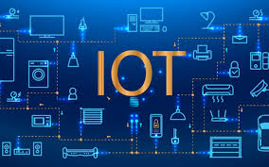 **Figure 1.1 : IOT**

The Internet of Things (IoT) refers to a network of physical objects, or "things," embedded with sensors, software, and connectivity that enable them to collect and exchange data with other devices and systems over the internet.

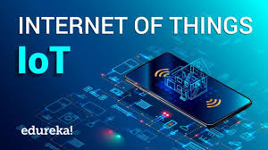

**Figure 1.2 : Internet of Things**

**BLOCK DIAGRAM OF IOT**

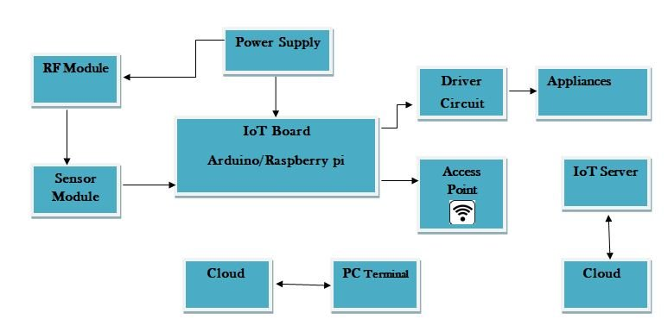

**Figure 1.3: Block diagram of IOT**

**Internet of Things architect**

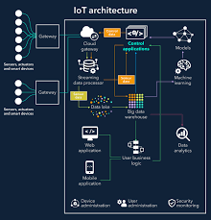

**Figure 1.4: Architecture of IOT**

## CHAPTER 2

## METHODOLOGY

### 2.1 Block Diagram of Smart Waste Management System

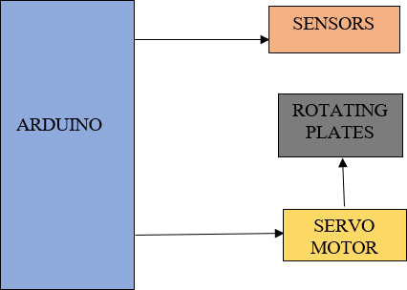

**Fig 2.1 methodology**

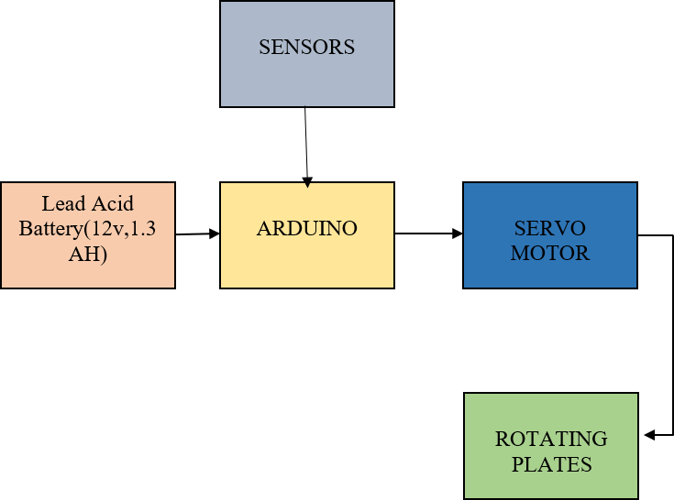

**Fig 2.2 Waste Management System**

[**Smart waste management**](https://evreka.co/)focuses on solving the previously mentioned solid waste management problems using sensors, intelligent monitoring systems, and mobile applications. The first smart waste management solution to make the waste collection process more efficient is sensors. Sensors can measure the fill level of the containers and provide updated information at any time and notify waste management services to empty them when they are full or almost full. These devices help optimize the best possible route containing fully filled containers and create smart schedules for drivers. The selection of the containers also minimizes the need for trash collection staff because their duties are deduced. They can also alert the waste management companies or municipalities if an undesirable incident happens such as sudden temperature rise or displacement of the container by their GPS features.

[**IoT solutions for solid waste management**](https://evreka.co/blog/how-iot-advances-smart-waste-management/) problems offer municipalities data intelligence and real-time insights. In that regard, the fill patterns of specific containers can be identified by historical data and managed accordingly in the long term. In addition to hardware solutions, mobile applications are used to overcome the challenges in the regular waste management system, such as keeping track of the drivers while they are operating on the field. Smart waste management is all about revolutionizing waste management using technology and data, thus creating a more efficient and sustainable way of managing waste.

Smart waste management also looks to solve the complexities associated with waste management overall – which isn’t just the amount of waste that needs to be processed, but also looking at how operational waste management can work better. Smart waste management is still considered a fairly new concept – with the first “smart” trash can being invented in 2013 in France.

Since then, various bins powered by technology and AI have surfaced, and commercial smart waste bins are in use across some of the biggest and most influential cities in the world. But, due to its newness – a lot of locations around the world are still becoming accustomed to smart waste management and how it can revolutionize the way that we view, process, and approach waste overall.

**What is a smart waste city?**

A smart waste city is a city that has implemented a smart waste management system to optimize the collection, processing, and disposal of waste. In a smart waste city, sensors and other technologies are used to monitor the amount and type of waste being generated, and to optimize the routes taken by waste collection trucks to minimize the environmental impact of waste management.

Smart waste cities may also use data analytics to identify trends in waste generation and to develop strategies to reduce the amount of waste being produced. Additionally, smart waste cities may use education and outreach programs to encourage citizens to reduce their waste and recycle more. By implementing a smart waste management system, cities can save money, reduce greenhouse gas emissions, and create a more sustainable future.

**An example of a smart waste city**

Amsterdam has implemented a number of innovative technologies to improve the efficiency and sustainability of its waste management system. For example, the city has implemented a smart waste collection system that uses sensors to monitor the fullness of trash cans, and to optimize the routes taken by waste collection trucks.This has helped to reduce the environmental impact of waste management and to save the city money. Amsterdam has also implemented a number of recycling programs, including a program that encourages residents to separate their waste into different bins for different types of materials.

Additionally, the city has implemented a composting program to divert organic waste from landfills and to create nutrient-rich compost for use in urban farming. These efforts have helped Amsterdam to significantly reduce its waste and to create a more sustainable future.

**COMPONENTS**

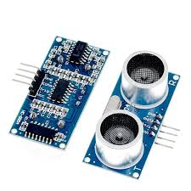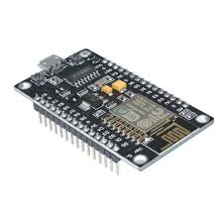

NODEMCU ESP8266

ULTRASONIC SENSOR

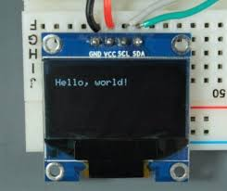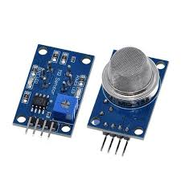

MQ 135 GAS SENSOR

OLED DISPLAY SENSOR

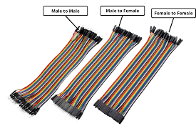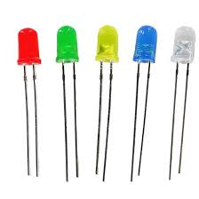

LED

JUMPER WIRES

**Figure : Components of SWMS**

**NODEMCU ESP8266**

The NodeMCU (***N***ode ***M***icro ***C***ontroller ***U***nit) is an open-source software and hardware development environment built around an inexpensive System-on-a-Chip (SoC) called the ESP8266. The ESP8266, designed and manufactured by Espressif Systems, contains the crucial elements of a computer: CPU, RAM, networking (WiFi), and even a modern operating system and SDK. That makes it an excellent choice for Internet of Things (IoT) projects of all kinds.

However, as a chip, the ESP8266 is also hard to access and use. You must solder wires, with the appropriate analog voltage, to its pins for the simplest tasks such as powering it on or sending a keystroke to the “computer” on the chip. You also have to program it in low-level machine instructions that can be interpreted by the chip hardware. This level of integration is not a problem using the ESP8266 as an embedded controller chip in mass-produced electronics. It is a huge burden for hobbyists, hackers, or students who want to experiment with it in their own IoT projects.

But, what about Arduino? The Arduino project created an open-source hardware design and software SDK for their versatile IoT controller. Similar to NodeMCU, the Arduino hardware is a microcontroller board with a USB connector, LED lights, and standard data pins. It also defines standard interfaces to interact with sensors or other boards. But unlike NodeMCU, the Arduino board can have different types of CPU chips (typically an ARM or Intel x86 chip) with memory chips, and a variety of programming environments. There is an Arduino reference design for the ESP8266 chip as well. However, the flexibility of Arduino also means significant variations across different vendors. For example, most Arduino boards do not have WiFi capabilities, and some even have a serial data port instead of a USB port.

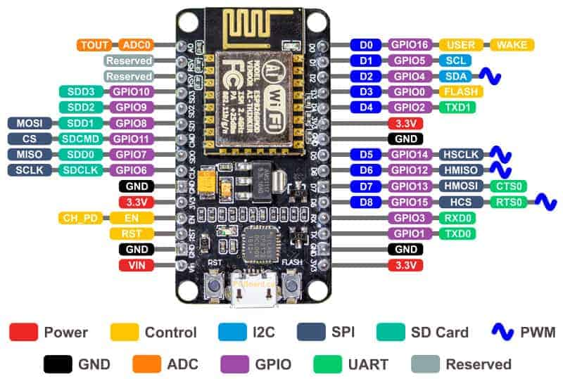

**Figure 1 :Nodemcu esp8266**

**ULTRASONIC SENSOR**

An ultrasonic sensor is an instrument that measures the distance to an object using ultrasonic sound waves. What is an ultrasonic sensor? It is a device that uses a transducer to send and receive ultrasonic pulses that relay back information about an object’s proximity. High-frequency sound waves reflect across boundaries to produce distinct echo patterns.

Ultrasonic sensors work by sending out a sound wave at a frequency above the range of human hearing. The transducer of the sensor acts as a microphone to receive and send the ultrasonic sound. Our sensors, like many others, use a single transducer to send a pulse and to receive the echo. The sensor determines the distance to a target by measuring time lapses between the sending and receiving of the ultrasonic pulse. This process is a key aspect of ultrasonic sensor working.

Ultrasound is reliable in any lighting environment and can be used inside or outside. Ultrasonic sensors can handle collision avoidance for a robot and being moved often, as long as it isn’t too fast.

Ultrasonics are so widely used that they can be reliably implemented in grain bin sensing applications, water level sensing, drone applications, and sensing cars at your local drive-thru restaurant or bank. Ultrasonic rangefinders are commonly used as devices to detect collisions.

Ultrasonic Sensors are best used in the non-contact detection of:

* Pressure
* Level
* Position
* Distance

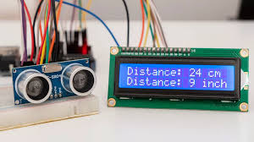

**Figure 2: Ultrasonic sensor**

**MQ 135 GAS SENSOR**

The gas sensing material used in the MQ135 gas sensor is tin dioxide (SnO2), which has low conductivity in clean air. When there is polluted gas in the environment where the sensor is located, the conductivity of the sensor increases with the increase of the concentration of polluted gas in the air. The MQ135 gas sensor has a high sensitivity to ammonia, sulfide, and benzene-based vapors, and is ideal for monitoring smoke and other harmful gases. This sensor can detect a variety of harmful gases and is a low-cost sensor suitable for a variety of applications.

Features

* Sensitive for benzene, alcohol, smoke
* Output voltage boosts along with the concentration of the measured gases increases
* Fast response and recovery
* Adjustable sensitivity
* Signal output indicator

Specifications

* Power: 2.5V ~ 5.0V
* Dimension: 40.0mm * 21.0mm
* Mounting holes size: 2.0mm
* 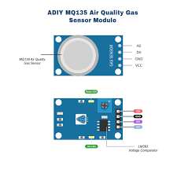Sensitive gases: ammonia, nitrogen oxides, alcohols, aromatic compounds, sulfides, fumes

**Figure 3: MQ 135 SENSOR**

**OLED DISPLAY SENSOR**

This article shows how to use the SSD1306 0.96 inch I2C OLED display with the Arduino. We’ll show you some features of the OLED display, how to connect it to the Arduino board, and how to write text, draw shapes and display bitmap images. Lastly, we’ll build a project example that displays temperature and humidity readings.

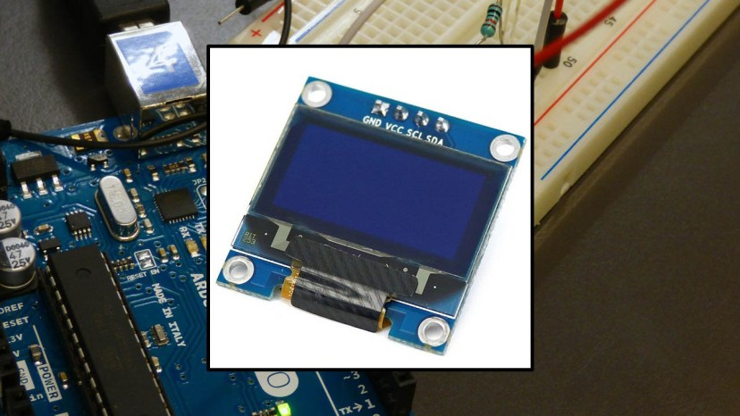

**Figure 4: Oled display**

The OLED display doesn’t require backlight, which results in a very nice contrast in dark environments. Additionally, its pixels consume energy only when they are on, so the OLED display consumes less power when compared with other displays.

The model we’re using here has only four pins and communicates with the Arduino using I2C communication protocol. There are models that come with an extra RESET pin. There are also other OLED displays that communicate using SPI communication.

**JUMPER WIRES**

Jumper wires are simply wires that have connector pins at each end, allowing them to be used to connect two points to each other without soldering. Jumper wires are typically used with [breadboards](https://blog.sparkfuneducation.com/what-is-a-breadboard) and other prototyping tools in order to make it easy to change a circuit as needed. Fairly simple. In fact, it doesn’t get much more basic than jumper wires.

Though jumper wires come in a variety of colors, the colors don’t actually mean anything. This means that a red jumper wire is technically the same as a black one. But the colors can be used to your advantage in order to differentiate between types of connections, such as ground or power.

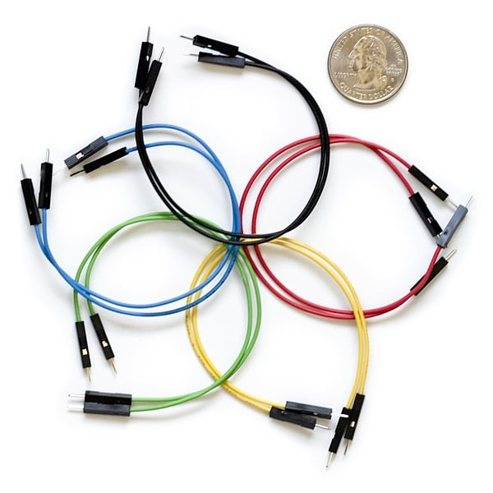Jumper wires typically come in three versions: male-to-male, male-to-female and female-to-female. The difference between each is in the end point of the wire. Male ends have a pin protruding and can plug into things, while female ends do not and are used to plug things into. Male-to-male jumper wires are the most common and what you likely will use most often. When connecting two ports on a breadboard, a male-to-male wire is what you’ll need

**Figure 5: Jumper wires**

**LED DISPLAY**

A **light-emitting diode** (**LED**) is a [semiconductor](https://en.wikipedia.org/wiki/Semiconductor) [device](https://en.wikipedia.org/wiki/Electronics) that [emits light](https://en.wikipedia.org/wiki/Light#Light_sources) when [current](https://en.wikipedia.org/wiki/Electric_current) flows through it. [Electrons](https://en.wikipedia.org/wiki/Electron) in the semiconductor recombine with [electron holes](https://en.wikipedia.org/wiki/Electron_hole), releasing energy in the form of [photons](https://en.wikipedia.org/wiki/Photon). The color of the light (corresponding to the energy of the photons) is determined by the energy required for electrons to cross the [band gap](https://en.wikipedia.org/wiki/Band_gap) of the semiconductor. White light is obtained by using multiple semiconductors or a layer of light-emitting [phosphor](https://en.wikipedia.org/wiki/Phosphor) on the semiconductor device.

Appearing as practical electronic components in 1962, the earliest LEDs emitted low-intensity [infrared](https://en.wikipedia.org/wiki/Infrared) (IR) light. Infrared LEDs are used in [remote-control](https://en.wikipedia.org/wiki/Remote_control) circuits, such as those used with a wide variety of consumer electronics. The first visible-light LEDs were of low intensity and limited to red.

Early LEDs were often used as indicator lamps, replacing small [incandescent bulbs](https://en.wikipedia.org/wiki/Incandescent_light_bulb), and in [seven-segment displays](https://en.wikipedia.org/wiki/Seven-segment_display). Later developments produced LEDs available in [visible](https://en.wikipedia.org/wiki/Visible_spectrum), [ultraviolet](https://en.wikipedia.org/wiki/Ultraviolet) (UV), and infrared wavelengths with high, low, or intermediate light output, for instance, white LEDs suitable for room and outdoor lighting. LEDs have also given rise to new types of displays and sensors, while their high switching rates are useful in advanced communications technology. LEDs have been used in diverse applications such as [aviation lighting](https://en.wikipedia.org/wiki/Navigation_light), [fairy lights](https://en.wikipedia.org/wiki/Christmas_lights), [strip lights](https://en.wikipedia.org/wiki/LED_strip_light), [automotive headlamps](https://en.wikipedia.org/wiki/Automotive_lighting#Light-emitting_diodes_(LED)), advertising, [general lighting](https://en.wikipedia.org/wiki/Lighting), [traffic signals](https://en.wikipedia.org/wiki/Traffic_light), camera flashes, [lighted wallpaper](https://en.wikipedia.org/wiki/LED_wallpaper), [horticultural grow lights](https://en.wikipedia.org/wiki/Grow_light), and medical devices.

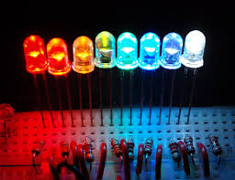

**Figure6 : LED**

### 

### 

### 2.1 Prototype of Smart Waste Management System

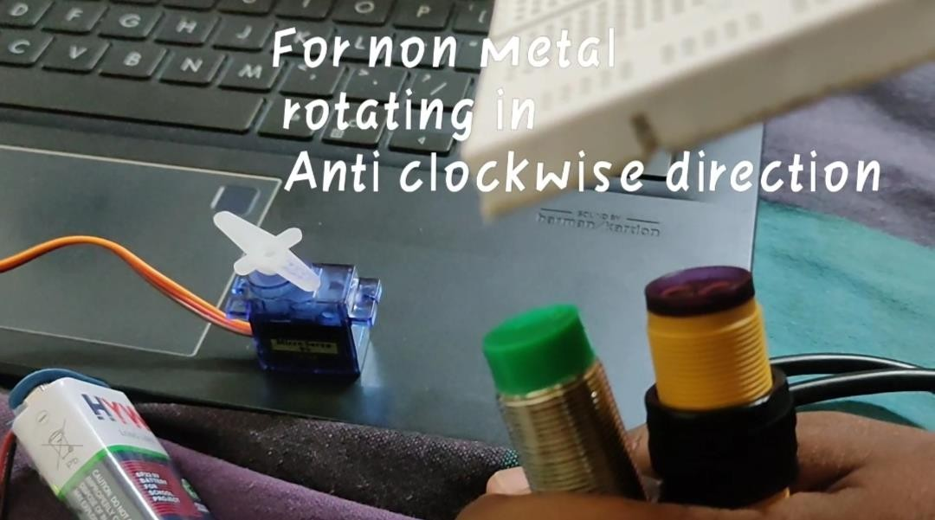

**2.2 Non metal rotating in anti clockwise direction**

# WET & DRY SEPARATION

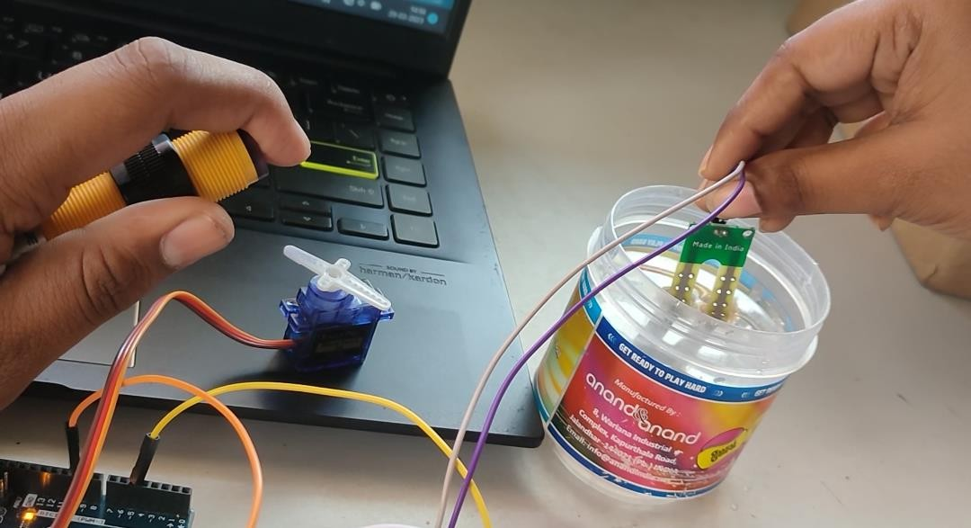

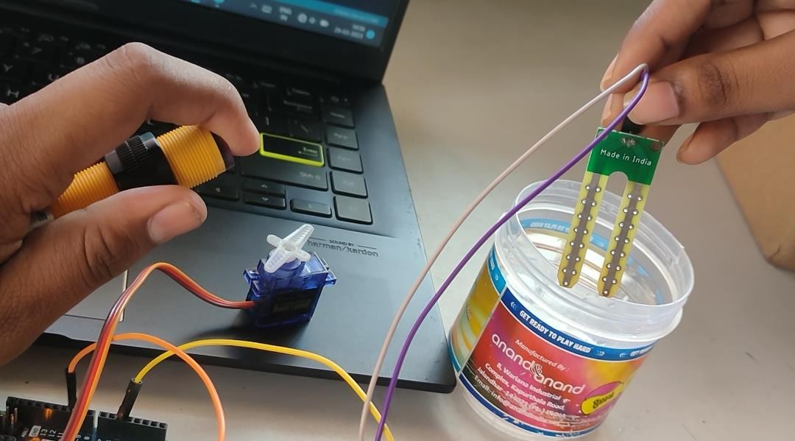

Fig 2.3 Controlling of Servo Motor

### Working Principle

The working of the complete smart waste control system is based on sensors, the response from the sensors make the work of servomotor which directs the waste materials in a particular direction.

Intially the waste that is placed on the primary plate there the wet and the dry waste will get separated. There we place a moisture sensor and a normal proximity sensor that detect presence of an object. Here how we are going to separate is taking response from both the sensors. If both the sensors give output value high that means it is a wet waste and the servo motor will rotate to 45 degrees in clockwise direction .

In another case only the proximity sensors will get high value that means it is a dry waste and the motor will go to angle 315 in clockwise direction. By that way wet and dry waste will get separated.

Now we have to separate metal and non-metals from dry waste for this have to an proximity sensor and Inductive proximity sensor which detect only metal objects. The separated dry waste got placed on plate 2 here the metallic sensor and proximity sensor readings will be taken and based on that response the plate using servomotor will be rotated.

If both the sensors give high value that will be consider as metal and the motor will rotate 45 degrees in anti-clock wise direction. If only proximity sensor got high value then it will be non-metal.

### Circuit Diagram

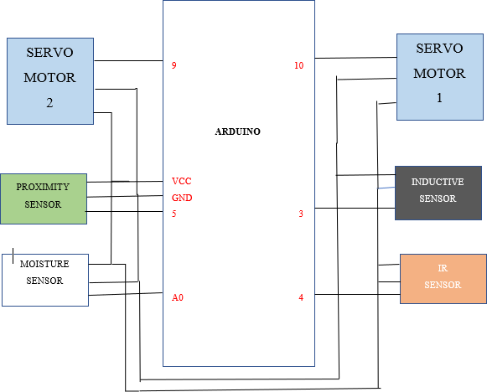

**Fig 2.4 Circuit Diagram servo motor**

This Circuit belongs to smart Waste control machine. This Circuit consists of Arduino

, Esp8266, Servo Motor, Lead Acid Battery , set of Sensors(Proximity Sensor, Inductive Proximity Sensor, IR Sensor , Ultrasonic Sensor, Moisture Sensor) . right here the Arduino is major controller of the entire circuit which collects the facts from all of the sensors and primarily based on the sensor reaction it controls the Servo Motor to rotate wherein attitude and the course.

The Moisture Sensor offers Analog value and the remaining all of the sensors deliver virtual price this is binary 1 or zero. For power we use Lead Acid Battery as we can rate it future . The Lead Acid Battery has two Terminals i.e superb and bad. The nice terminal is attached with Vcc of Node MCU and negative terminal is connected with Gnd pin of Arduino.

Initially when the garbage is thrown it will check for wet or the dry Waste. For that we used proximity sensor and moisture sensor. Here a simple LOGICAL AND operation is used. We have kept some threshold value for moisture sensor i.e if the value is above that moisture level then we can say it wet waste or else it will be dry waste. Here the moisture sensor gives value above that threshold and proximity sensor gives value 1 then it will be consider as wet waste then the servo motor will be rotated in clock wise direction .

If only Proximity sensor gives the value and there is no response from the moisture sensor the it will dry waste then the servo motor will rotate in opposite direction.

In dry waste we again separate that into metal and non-metal. For that we use Inductive Proximity sensor for metal detection. Here we the same LOGICAL AND operation if only Proximity Sensor gives Digital 1 then it is Non-Metal the servo motor will be rotated in clock-wise direction. If both the metal sensor and the proximity sensor gives the response then it is a metal waste and the servo motor will be rotated in opposite direction

### Implementation of Smart Waste Management System

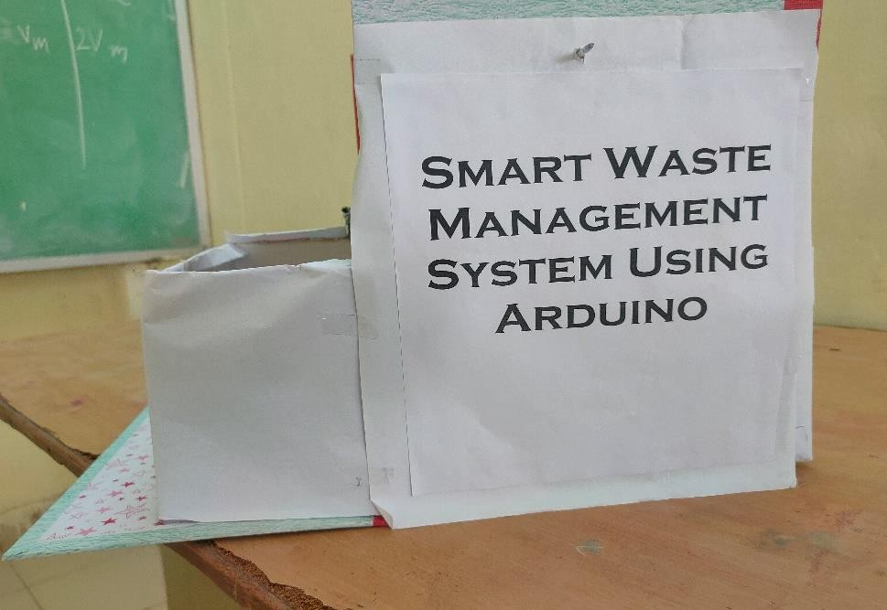

**Fig 2.5 Smart Waste Management System**

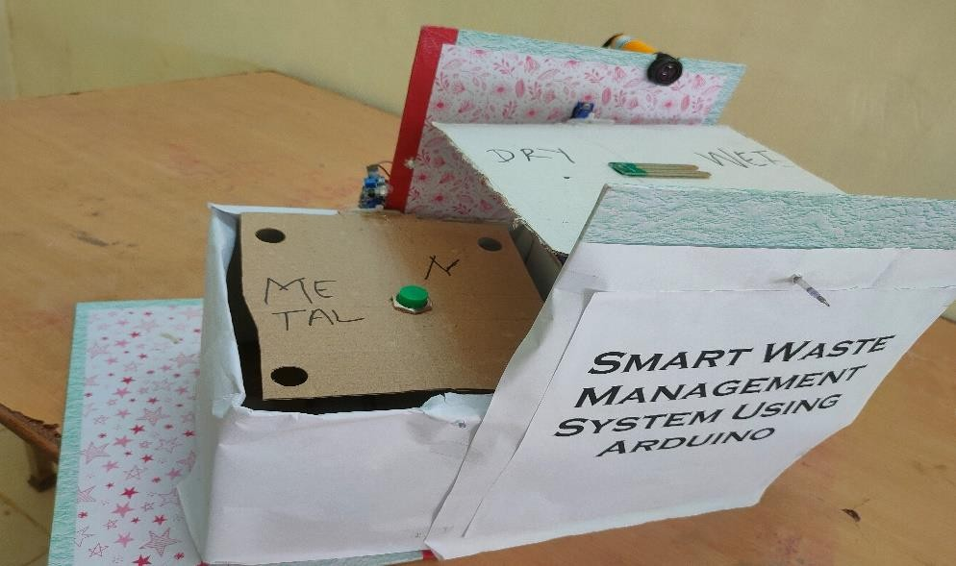

**Fig 2.6 Implementation of Smart Waste Management System**

## CHAPTER 3

**SOFTWARE REQUIRED**

### Arduino IDE:

**Arduino IDE** is the software program used to operate the Arduino board. The software program is used as a text editor to create, open, edit and examine Arduino code. The code or program in Arduino is known as a "comic strip".

The Arduino incorporated development surroundings (IDE) is a software program program for writing, writing and uploading code to the Arduino board. It provides an easy-to-use interface for programming Arduino boards and simplifies the code era and add process.

The Arduino IDE is primarily based on a programming language and open supply, which means it's loose to apply and may be modified by way of every body. it's miles to be had for windows, Mac OS X and Linux working structures. Arduino IDE includes code editor, compiler, bootloader and serial reveal.

The code editor is used to write and edit Arduino code based on the C/C++ programming language. The compiler is used to convert the code into a format the Arduino board can understand and the bootloader is used to upload the code to the board. The serial monitor is used to communicate with and receive data from the development board.

Overall the Arduino IDE is a must-have tool for all Arduino board development users as it simplifies the process of working and passing code to the board leader. Its user- friendly interface and clear nature make it popular with hobbyists, students and professionals.

## INSTALLING ARDUINO IDE:

Step 1: Download the Arduino IDE file To download the free software, click the following link in any explorer:

There are 3 download alternatives for home windows on this web page.

1. windows Installer: This software might be installed within the windows running gadget and ought to have administrator rights.
2. home windows Zip document: rau transportable installation.
3. home windows application: Rau windows 8.1 Losis 10.

**Step 2**: Installation Option

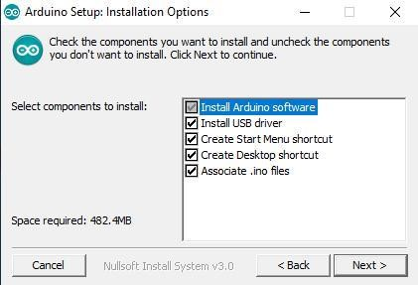

**Fig 3.1 Arduino Installation**

**Step 3**: Destination File

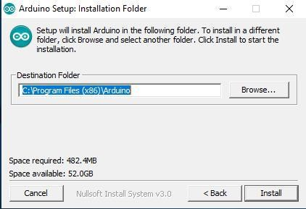

Arduino will automatically be established in "C:program files (x86)Arduino".

1. in case you want to alternate the folder, click on "Browse" and pick out the preferred folder.
2. click deploy to start the installation.

**Step 4**: Setup installation

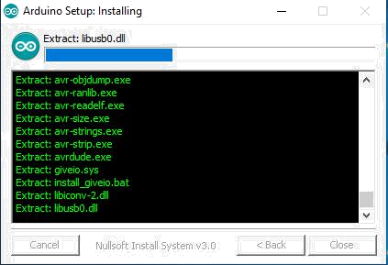

Fig 3.2 Arduino Setup

**Step 5**: Setup Unit Completed

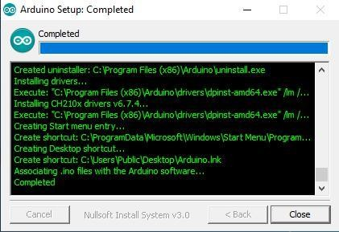

**Fig 3.3 Arduino software installation**

If there may be written "whole", it method that the installation manner is complete. click "near".

**Step 6**: View Arduino IDE

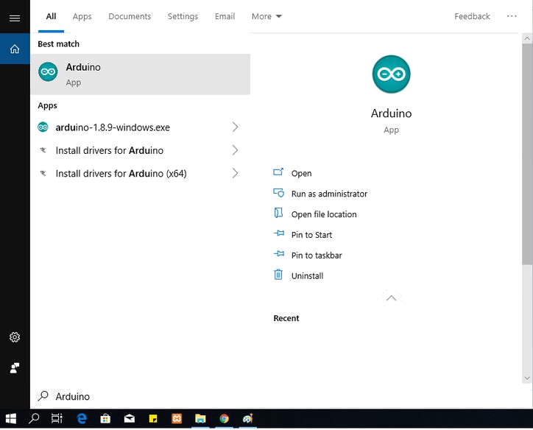

**Fig 3.4: Arduino IDE**

whilst the set up method is whole, the Arduino icon will seem on the laptop. Or draw the quest icon and type "arduino". in case you see the Arduino icon, run the software.

**Step 7:** Show ArduinoIDE

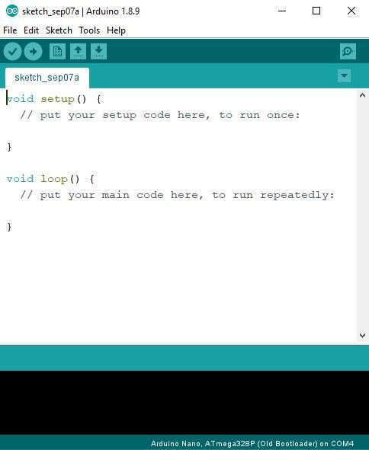

**Fig 3.5 : Show case Arduino IDE**

That is a show of the Arduino IDE software.

**CHAPTER 4**

**HARDWARE REQUIRED**

## COMPONENTS REQUIRED

1. Arduino Uno
2. Inductive Proximity Sensor
3. Proximity sensor
4. IR sensor
5. Moisture sensor
6. Servo Motor
7. Lead Acid Battery
8. Rotating Plates
9. Connecting Jumper wires

### Arduino Uno

Arduino Uno is an ATmega328P based totally microcontroller board. It has 14 input/output pins (6 of which can be used as PWM outputs), 6 analog inputs, 16 MHz ceramic resonator (CSTCE16M0V53-R0), USB connection, energy enter, ICSP header and reset button. microcontroller; simply join it to a laptop with a USB cable or strength it with an AC-DC adapter or battery and you are geared up to head.

You may tamper with your Uno and not worry too much about doing some thing incorrect, you can update the chip for a couple of dollars and begin over. Arduino UNO is the high-quality development board for getting started out with electronics and coding. If that is your first enjoy with the platform, UNO is the most powerful board you can start playing with. UNO is the most available and quality model of the whole Arduino own family. "Uno", which means "Uno" in Italian, became used to mark the discharge of Arduino software program (IDE) 1.0. Uno board and version 1.

Arduino software program (IDE).zero is the consumer model of Arduino advanced for a new version. The Uno board is the primary of the USB Arduino board and is the reference board for the Arduino platform; See the Arduino Board Index for a complete list of present day, past or modern-day forums. The Uno differs from all previous forums in that it does not use a FTDI USB to UART serial chip, even as communicating the use of the original STK500 protocol. as an alternative, it uses an Atmega16U2 (Atmega8U2 from R2 upgrade) programmed as a USB.

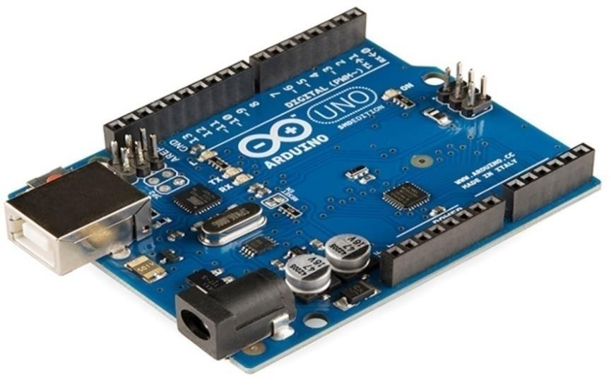

**Fig 4.1 Arduino**

### Pin Configuration of Arduino Uno

**Fashionable pin functions functions**

LED: Onboard LED driven by pin 13. When the pin is high the LED is on and when the pin is low the LED is off.

VIN: Input voltage to Arduino board when using external power (about 5 volts from USB connection or other power management). You can supply

voltage from this pin, or if you are supplying voltage from a power supply, you can access it from this pin.

5V: This pin allows 5V from the on-board controller. The board can be powered by DC power supply (7 - 20V), USB connection (5V), or the board VIN pin (7-20V). Supplying power from the 5V or 3.3V pins will bypass the controller and may damage the board.

3V3: 3.3 volt supply generated by the built-in voltage regulator. The maximum current is 50 mA.

GND: START. • IOREF: The pin on the Arduino board provides the voltage on which the microcontroller operates. A properly configured circuit board can read the IOREF pin voltage and select the appropriate input or output voltage to work with 5V or 3.3V.

RESET: Usually used to add a reset button to the shield button on the shield.

### 

### Special pin capabilities

Every of the 14 virtual and six analog pins at the Uno may be used as an enter or output based totally on software program manage (the usage of the pin Mode(), digital Write() and digital Read() features).

They function at 5 volts. each pin can get preserve of or obtain 20 mA steady with the encouraged operation and has an internal pull-up of 20-50K ohms (unconnected through default). The most modern-day drawn from an I/O pin need to not exceed 40mA to keep away from eternal harm to the microcontroller.

The Uno has 6 analog inputs classified A0 thru A5; every offers 10-bit resolution (eg. to. 1024 unique values). by means of default, they degree as much as five volts from floor, however the top restrict of the range may be modified using the AREF pin and the analog Reference() function.

Further, a few pins have specialised functions:

* **Serial/UART**: Pins zero (RX) and 1 (TX). TTL is used to obtain (RX) and transmit (TX) serial facts. those pins connect to the corresponding pins at the ATmega8U2 USB-to-TTL serial chip.
* **External interrupt:** Pins 2 and three. these pins can be configured to cause an interrupt on a low price, rising or falling area, or value change.PWM (pulse-width modulation): pins 3, five, 6, 9, 10, and eleven. Can provide eight-bit PWM output with the analogWrite() characteristic.
* **SPI (Serial Peripheral Interface):** Pins 10 (SS), eleven (MOSI), 12 (MISO) and 13 (SCK). those pins help SPI communique using the SPI library.
* **TWI (Two-Wire Interface)/I²C**: pin SDA (A4) and pin SCL (A5). TWI communication is supported using Wire Library.
* **AREF** (Analog Reference): Reference voltage for analog input.

### Communication

Arduino Uno has many tools for speaking with a laptop, every other Arduino board or other microcontrollers. The ATmega328 provides UART TTL (5V) serial communication placed on pins zero (RX) and 1 (TX).

The ATmega16U2 on the motherboard takes the USB communication interface and looks as a digital port for computer software program. The 16U2 firmware makes use of general USB COM drivers and does not require outside drivers. however, on home windows a. inf record is required.

The Arduino software (IDE) includes a controller that lets in smooth sending and receiving of records to and from the board. The RX and TX LEDs at the board will flash whilst sending information to the laptop through the USB-serial chip and USB connection (however now not for communication among pins 0 and 1).

The serial software library allows conversation thru any of the Uno's digital pins. The board has two 5V pins, 3V3 pins and seven ground pins (0V).

### Automatic (software) reset

The Arduino Uno board is designed so that it could be rebooted from software jogging on the connected laptop, in place of bodily urgent the reset button earlier than uploading.

One of the voltage regulator traces (DTR) of the ATmega8U2 / 16U2 is hooked up to the reset line of the ATmega328 thru a one hundred nanofarad capacitor. while this line is stated (pulled down), the reset line drops sufficient to reset the chip. This configuration has another impact.

While the Uno is hooked up to a laptop jogging Mac OS X or Linux, it resets every time a connection is made through software (thru USB). For 1/2 a 2nd, the bootloader works on Uno. while programmed to ignore invalid information (other than uploading new code), it captures the primary few bytes of information sent to the clipboard after beginning the relationship.

### Specifications of Arduino Uno

* Microcontroller: ATmega328P operating Voltage: 5V
* input Voltage (pom zoo): 7-12V input Voltage (restrained): 6-20V
* virtual I/O Pins: 14WM (6 Output four) PWM digital I /O pins: 6
* Analog input pins: 6
* DC modern-day in step with I/O pin: 20 mA DC full sim no rau three.3V pins: 50 mA
* Flash: 32 KB (ATmega328P) and its zero ,five KB bootloader SRAM: 2 KB (ATmega328P)
* EEPROM: 1 KB (ATmega328P)
* Clock : 16 MHz
* operating Voltage: 5V
* enter Voltage (encouraged): 7-12V Inout Voltage (restrict): 6-20V
* digital I/O Pins: 14 (of which 6 offer PWM output) PWM virtual I/O Pins: 6
* Analog input Pins: 6
* DC cutting-edge consistent with I/O Pin: 20 mA DC cutting-edge for three.3V Pin: 50 mA
* Flash reminiscence: 32 KB of which zero.five KB utilized by bootloader SRAM: 2 KB (ATmega328P)
* EEPROM: 1 KB (ATmega328P)
* Clock pace: 16 MHz LED_BUILTIN:13
* length: sixty eight.6 mm Width: fifty eight.4 mm Weight: 25 g

## SENSORS

### Inductive Proximity Sensor

Inductive proximity sensors can locate metallic goals near the sensor without making contact with the target. Inductive proximity sensors are divided into 3 kinds according to their working patterns: high-frequency oscillating type using electromagnetic induction, magnetic kind the usage of magnets, and capacitive kind the use of capacitance alternate.

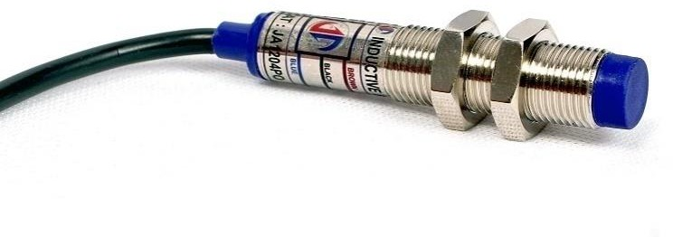

**Fig 4.2 Inductive Proximity Sensor**

### Specification of Inductive Proximity Sensor

* + - * Sensing distance: 2 mm ± 10%, 4 mm ± 10%, 5 mm ± 10%, eight mm

± 10%,12 mm ± 10%

* + - * Differential travel: max. 10% of sensing distance
      * Detectable item: Ferrous steel
      * power deliver Voltage (working Voltage variety): 12 to 24 VDC, ripple (p-p): max. 10%
      * modern-day intake: 15 mA max
      * Output Load modern: 200 mA max

Residual voltage: 2V max. (load contemporary: 200 mA, cable period: 2 m)

* + - * indicators: Operation indicator (purple)
      * Operation Mode (with Sensing object approaching): NPN: NO / NC; PNP: NO / NC
      * Ambient Temperature range:

– working: working: -25 ~ +70 ºC / garage: – 40 ~ eighty ºC (and not using a icing or condensation)

* + - * Connection technique: 3 wires 2m cable and M12 connector with 200mm cable.

### Working of Inductive Proximity Sensor :

Inductive proximity sensors come across magnetic area loss because of eddy present day-day created thru the outside magnet of electrical tool. An AC magnetic area is created through the sensing coil to experience the impedance trade because of the eddy cutting-edge produced on the metal object.

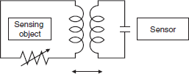

**Fig 4.3 Working of Inductive Proximity Sensor**

different methods consist of aluminum detection sensors that hit upon the frequency- to-segment level, and all-steel sensors that use coils to hit upon the impedance exchange of the product. There are also impulse response sensors that create eddy contemporary in pulses and stumble on the time variation of eddy modern with voltage induced in the coil.

The change-like coupling is changed by way of impedance trade because of eddy contemporary loss. The alternate in impedance may be considered because the change in resistance positioned in series with the source.

### Proximity Sensor :

E18-D80NK adjustable infrared sensor switch 3-80cm is a photoelectric switch sensor integrating transmitter and receiver. The measured distance may be adjusted as wanted. The measuring variety of the size is three-80 cm.

The adjustable infrared sensor transfer is small, smooth to use, low cost, and easy to put in. it can be broadly used in lots of conditions, which includes robot safety, verbal exchange and meeting traces. alternate the output sign differently with boundaries. stay excessive whilst there is no hassle and stay low while there is a hassle. there may be a robust mild behind the probe, and the detection variety is 3cm-80cm.

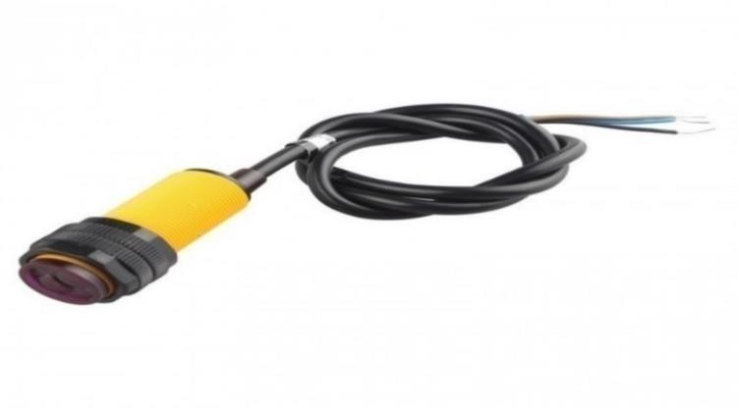

**Fig 4.4 Proximity Sensor**

### Connections:

* + - Brown wire: +5v
    - Blue cord: GND
    - Black wire: digital output.

### Specifications :

Luminescence fount - Infrared Discern gamut - 3cm – 80cm Load Potential - 5v contemporary - 300mA

Cord extent - 1meter

### Working of Proximity Sensor:

In comparison to sensors which include restrict switches that hit upon items by bodily contact, proximity sensors encompass all non-contacting sensors. Proximity sensors convert records about the movement or presence of items into electrical alerts. There are 3 sorts of detectors which could make this modification: machines that use the eddy current created by using electromagnetic induction of metallic items, machines that detect modifications in potential up to the tool, and machines that use magnets and magnetic switches.

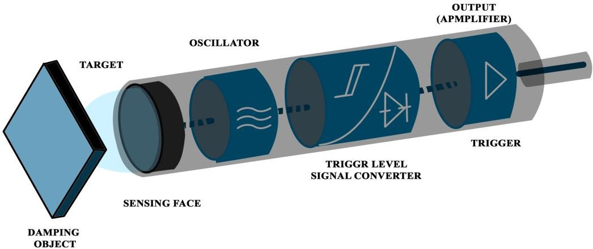Proximity sensors specified in JIS C 8201-five-2 (Low voltage switchgear and manage equipment, element five: manage gadgets and switches, component 2: Proximity switches) in compliance with TS EN 60947-five-2 standards (JIS) IEC 60947 -5-2 Contactless type role sensing switch definition.

**Fig 4.5 Working of Proximity Sensor**

### Moisture Sensor

A humidity sensor, also called a humidity sensor or hygrometer, is an electronic tool that measures the humidity or humidity of the surrounding environment. Humidity sensors are frequently used in many programs which includes agriculture, home automation and commercial processes.

The Humidity Sensor works by detecting changes in resistance, capacitance, or other physical properties that are affected by humidity or humidity. They usually have a sensor element made of a material that detects humidity or changes in humidity, and an electronic sensor that measures the meter's output and is converted into a reading.

The Humidity Sensor may be used to screen and manipulate humidity in numerous areas. for example, in agriculture, moisture sensors can be used to screen soil moisture and optimize irrigation in real time, at the same time as in domestic automation they may be used to manipulate HVAC structures to display humidity and preserve indoor situations.

In industrial processes, moisture meters are used to monitor the moisture content of materials such as wood, paper and textiles to maintain quality and prevent defects. In general, the humidity sensor is a useful tool for many applications where it is important to control and monitor humidity.

via providing accurate and dependable measurements, they are able to help enhance tactics, reduce waste and growth average productivity. The Soil Moisture Sensor measures the moisture content of the soil. since the direct gravimetric dimension of soil moisture calls for eliminating, drying, and weighing the sample, a soil moisture meter directly measures the quantity of the soil the usage of positive residences of the soil, which include electric resistance, permeability, or interactions with neutrons. representatives of moisture. contents

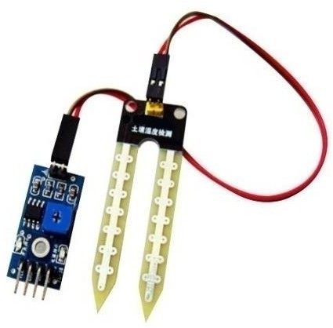

**Fig 4.6 Moisture Sensor**

### Specifications Of Moisture sensor

* running Voltage: 3.3V to 5V DC
* running modern: 15mA
* Output digital - 0V to 5V, Adjustable trigger level from preset
* Output Analog - 0V to 5V based on infrared radiation from fireplace flame falling at the sensor
* LEDs indicating output and electricity
* PCB size: three.2cm x 1.4cm
* LM393 based totally layout

### Working of Moisture Sensor:

A soil moisture meter measures the amount of water in the soil and can be used to estimate water garage within the soil layer. Soil moisture sensors do no longer measure soil moisture without delay. alternatively, they predictably measure changes in different soils related to water content material.

Every producer uses a special approach to degree soil moisture. an electrical device known as a capacitor has three components. the space between the nice plate, the terrible plate and the plate is known as the dielectric. real capacitors vary in physical form and production, and distinctive types of capacitors are commonly used. most capacitors contain as a minimum two electrodes, commonly within the shape of steel or separated by using a dielectric medium.

A capacitive moisture sensor works by means of measuring the modifications in capacitance as a result of the changes inside the dielectric. It does no longer measure moisture at once (pure water does now not conduct strength nicely), as a substitute it measures the ions which are dissolved within the moisture those ions and their concentration may be laid low with more than a few of things, as an instance adding fertilizer as an instance will lower the resistance of the soil.

Capacitance measures the dielectric medium created via the soil, and water is the maximum critical thing influencing the dielectric.

The capacitance of the sensor is measured with a 555-primarily based circuit that produces a voltage proportional to a capacitor located to ground. This voltage can be measured the usage of an analog-to-digital converter (ADC) that produces a number we will interpret as humidity. The final release charge is stricken by how deep the probe is inserted and how compact the surrounding soil is. Value_1 is the value for dry soil and Value_2 is the cost for saturated soil.

* + 1. **Infrared (IR) sensor**

An infrared (IR) sensor is an electronic device that measures and detects infrared radiation in the surrounding environment. In 1800, astronomer William Herchel discovered infrared radiation.

When measuring the temperature of each color of light (separated by prisms), only red light is found to have the highest temperature. Infrared is invisible to the human eye, as it has a longer wavelength than visible light (although still in the same electromagnetic spectrum). Anything that emits heat (anything with a temperature higher than five degrees Kelvin) emits infrared radiation.

An infrared sensor, also known as an infrared sensor, is an electronic device that detects electromagnetic radiation in the environment. Infrared radiation is a type of radiation emitted by any material whose temperature is above zero. Infrared sensors are frequently used in many applications such as temperature measurement, motion detection and remote control.

The Infrared Sensor works by detecting changes in the intensity of infrared radiation at a particular wavelength. They have emitters that produce infrared radiation and detectors that capture the radiation and convert it into an electrical signal.

Detection equipment is usually made of infrared radiation sensitive materials such as thermopiles or bolometers. The Infrared Sensor has many applications. For example, they can be used to measure the temperature of an object without touching its body, making them useful in applications such as industrial process control, medical imaging, and building automation. Infrared sensors are also used in security systems and motion detection devices, as they can detect people or objects based on changes in infrared radiation.

Finally, IR sensors are often used in remote controls of electronic devices such as TVs and DVD players so that users can control them remotely.

### Specifications

* 5V DC running voltage
* I/O pins 5v and three.3v
* variety upto 20cm
* Adjustable sensing variety
* built in ambient mild sensor
* 20mA deliver voltage
* 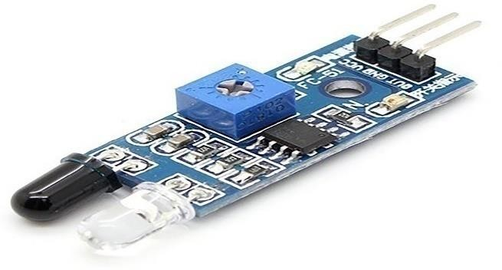Mounting hollow

**Fig 4.7 IR Sensor**

### Working of IR Sensor :

Active infrared sensors work in conjunction with radar technology, simultaneously emitting and receiving infrared radiation. These electrons hit nearby objects and return to the receiving device.

With this technology, the sensor detects not only the movement of the environment, but additionally how near the object is to the device. this is in particular useful in robotics to govern proximity. Infrared radiation paperwork the lower quit of the electromagnetic spectrum and consequently is invisible to the human eye.

The infrared part of the electromagnetic spectrum is among seen waves and microwaves. Infrared wavelengths range from zero.75 to one thousandµm and are divided into 3 zones. Infrared radiation is function of all materials with a temperature above zero (zero Kelvin or -273 ranges Celsius).

Those items are thermal and emit infrared waves. Infrared sensors commonly use infrared lasers and LEDs with infrared wavelengths. For thermal electricity to attain the infrared scale, it ought to use a transmission medium. the published medium is air, vacuum or fiber optic.

Optical lenses made from a combination of metals and materials such as quartz, calcium fluoride, polyethylene, germanium, aluminum and silicon are used as electronic components. The light or spotlight is then detected by an infrared detector. Infrared detectors require a preamplifier to amplify the signal.

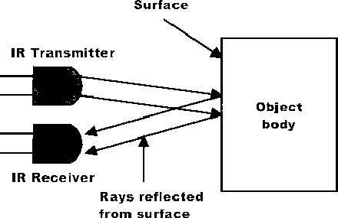

**Fig 4.8 Working of IR Sensor**

## LEAD ACID BATTERY

Lead acid batteries have electrodes immersed in a sulfuric acid electrolyte. The positive electrode is made of lead oxide whilst the negative electrode is hooked up to the lead grid. There are types of lead-acid batteries: flooded and valve-regulated. Acid flooded batteries are much less high-priced than acid manage valve batteries, but require greater upkeep and air flow. Lead-acid batteries are transportable.

The price is low. but, those batteries face many problems throughout their lifetime, including low price, low strength intake, short existence and gradual charging. extra superior lead-acid batteries are being brought.

The brand new lead acid battery makes use of carbon monoxide on the terrible electrode to form a poor electrode supercapacitor. In those batteries, the chemistry of the wonderful electrode does not trade in any manner, and the chemistry of the bad electrode does no longer. therefore, the coolest electrode is less vulnerable to corrosion, ensuing in longer life and better performance than lead-acid batteries.

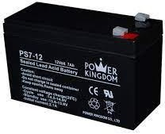

**Fig 4.9 Lead Acid Battery**

### Servo Motor

A servo motor is a field device or power line that provides particular manage of attitude or immediately line, speed and velocity. It has a suitable frame connected to the sensor for the remarks feature. It additionally calls for a extraordinarily complex controller, commonly a unique module designed to be used with servo cars.

It isn't always a specific motor elegance, however the time period servo motor is often used to consult automobiles appropriate to be used in closed loop manage systems. The Servo Motor is a powerful motor often used in many packages inclusive of robotics, production and automation. it is an digital field that offers unique manipulate of angular role, speed and acceleration.

The servo motor operates by receiving a control signal that determines the desired position of the motor shaft. The control signal is usually in the form of a pulse width modulated (PWM) signal, in which the pulse timing determines the desired position. The servo motor then uses the feedback from the internal sensors to adjust the position of the motor until it matches the desired position.

Servo Motors are popular in robotic applications due to their ability to accurately control the position and speed of robotic joints. They are also frequently used in manufacturing and electronics, where they can be used to control the position of conveyor belts, robotic arms, and other mechanical systems. In addition to their precise control capabilities, Servo motors are known for their high electrical properties that allow them to move heavy objects with ease.

They are available in various sizes and torque ratings for a variety of applications. In general, servo motors are a popular choice for applications that require precise control of motor position and speed. Their ability and versatility to deliver high output torque make them useful tools for a variety of industries and applications.

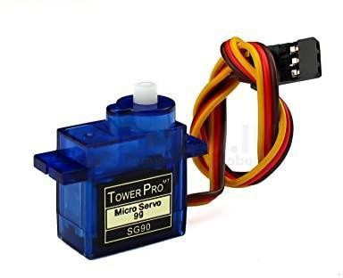

**Fig 4.10 Servo Motor**

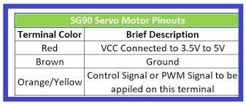

**Fig 4.11 Servo Motor Pin Description**

A servomotor is a "servomotor-controlled" motor. Servos use sensors to track the position of the motor shaft and actuators to control the motor. Receives a signal indicating where the axis should be set. It then moves the motor to the desired position. When simulating a servo motor, we use a control signal whose pulse width is a PWM signal that determines the angle of the motor shaft. The motor itself is a simple DC motor with a lot of power to reduce speed and increase torque. In order for the servo motor to work properly, it needs a sensor that can measure the position of the shaft. In some commercial and high-end servos this is done with an optical marking disc, but in most standard hobby servos the sensor is a potentiometer. This works well because the servos move between 180 and 270 degrees, which is usually within the range of the potentiometer.

**PROJECT CODE:**

#include <Wire.h>

#include <U8g2lib.h>

#define TRIG_PIN 14 // D5

#define ECHO_PIN 12 // D6

#define MQ_PIN A0

#define BUZZER_PIN D0

#define LED_PIN D3 // Added LED pin

// Initialize U8g2 for I2C OLED

U8G2_SSD1306_128X64_NONAME_F_SW_I2C u8g2(U8G2_R0, /* clock=*/ D1, /* data=*/ D2, /* reset=*/ U8X8_PIN_NONE);

void setup() {

Serial.begin(115200);

pinMode(TRIG_PIN, OUTPUT);

pinMode(ECHO_PIN, INPUT);

pinMode(BUZZER_PIN, OUTPUT);

pinMode(LED_PIN, OUTPUT); // Set LED as output

// Initialize OLED display

u8g2.begin();

}

void loop() {

int GasValue = analogRead(MQ_PIN);

Serial.print("GAS Value:");

Serial.println(GasValue);

long duration;

float distance;

// Trigger the sensor

digitalWrite(TRIG_PIN, LOW);

delayMicroseconds(2);

digitalWrite(TRIG_PIN, HIGH);

delayMicroseconds(10);

digitalWrite(TRIG_PIN, LOW);

// Read echo pulse duration

duration = pulseIn(ECHO_PIN, HIGH);

// Convert duration to distance (in cm)

distance = (duration * 0.0343) / 2;

String status;

if (distance <= 5) {

status = "\xe2\x9a\xa8 Heavy Load"; // 🚨

digitalWrite(BUZZER_PIN, HIGH);

digitalWrite(LED_PIN, HIGH); // Turn LED ON

} else if (distance > 5 && distance <= 15) {

status = "\xe2\x9a\xa0 Loaded"; // ⚠️

digitalWrite(BUZZER_PIN, LOW);

digitalWrite(LED_PIN, LOW); // Turn LED OFF

} else if (distance > 15 && distance <= 25) {

status = "\xe2\x9c\x85 Normal"; // ✅

digitalWrite(BUZZER_PIN, LOW);

digitalWrite(LED_PIN, LOW);

} else {

status = "\xf0\x9f\x9f\xa2 Very Normal"; // 🟢

digitalWrite(BUZZER_PIN, LOW);

digitalWrite(LED_PIN, LOW);

}

Serial.println(status);

// Display on OLED

u8g2.clearBuffer();

u8g2.setFont(u8g2_font_ncenB08_tr);

u8g2.setCursor(0, 20);

u8g2.print("Dustbin Level:");

u8g2.setCursor(0, 35);

u8g2.print("Distance: ");

u8g2.print(distance);

u8g2.print(" cm");

u8g2.setCursor(0, 55);

u8g2.print(status);

u8g2.sendBuffer();

delay(1000); // Wait 1 second before next reading

}

**RESULT:**

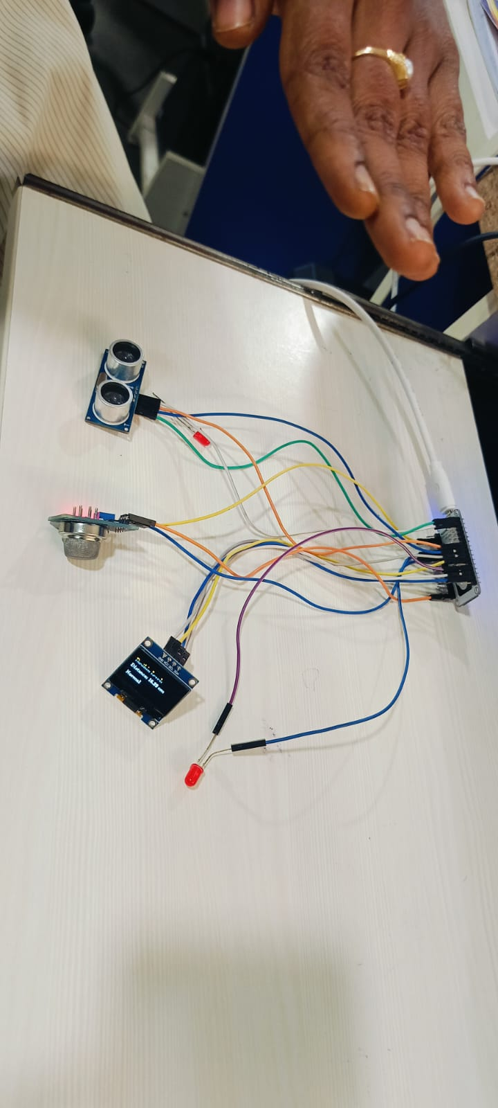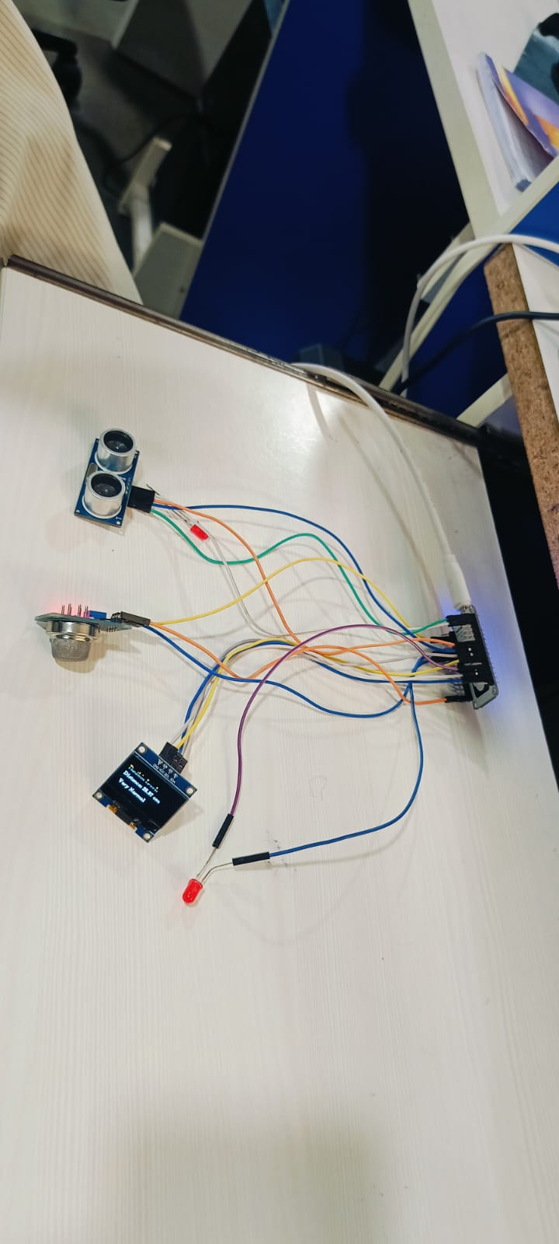

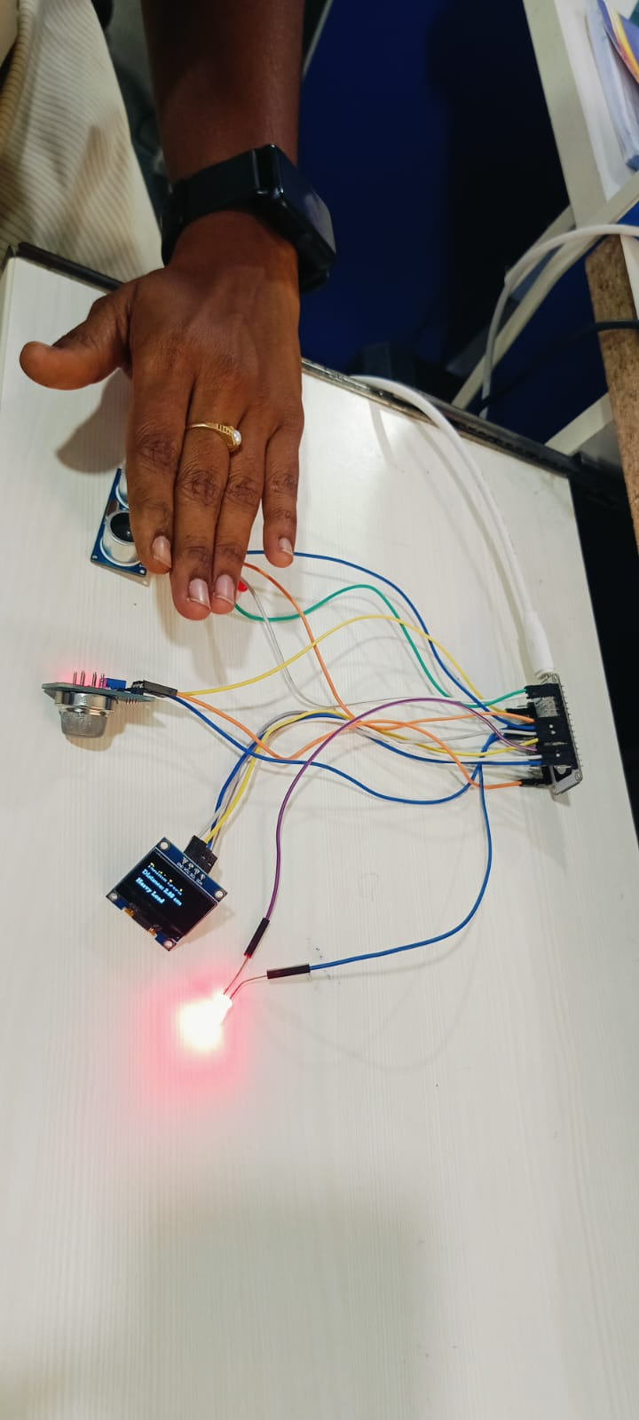 **VERY NORMAL DISTANCE NORMAL DISTANCE**

**HEAVY LOAD DISTANCE**

**OUTPUT SCREENS**

Detection of URL:

GITHUB LINK: <https://github.com/Vennela434/Smart-Waste-Management-System>

Github cli **repository to a custom directory:**

gh repo clone Vennela434/SWMS

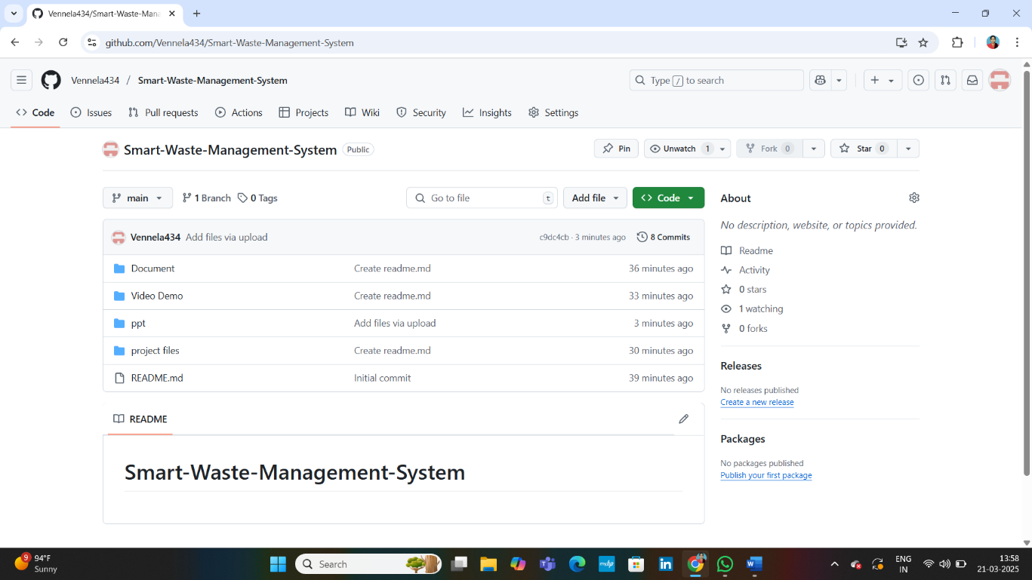

CONCLUSION

As there many Smart Waste Management and segregation systems developed in the past , in real implementation there were some flaws in that where we can only separate the wet and dry. As per research the metal objects present the waste or the garbage are way harmful then plastic , which pollute environment. The metal is also way useful for many purposes , so we aimed to separate the metal from waste. Here Arduino is the main heart of our system which completely controls the servo motor rotation so the separation was done.

As of now moist and parched squander got separated and in dry waste the metal as well as non-metal got separated. In non-metal we have paper, wood, plastic etc. After the complete implementation of this prototype in future we can look into the separation of plastic which is one of the major pollutants in our environment.

We can improve the performance of the system by going with high level sensors with better specification which may have better accuracy and response times. The sensors we have used were basic level sensors through which we can get exact prototype of our idea. We can also inferface this circuit with blynk application to live status of the bin so that whenever it is filled the management team will collect it. So then we can call it as complete waste management system .

## REFERENCES

1. Waste Management Indicators. Accessed: May 2021. [Online]. vailable: https://ec.europa.eu/eurostat/statistics-explained/index.php?title=Waste_ management_indicators#Overview
2. H. Jabar, R. Hassan and A. S. Sadeq, "A New Smart Waste Managing System," 2020 International Conference on Computer Science and Software Engineering (CSASE), Duhok, Iraq, 2020, pp. 209-214, doi: 10.1109/CSASE48920.2020.9142068.
3. S.Paul, S. Banerjee, & S. Biswas, " Smart Garbage Monitoring Using IoT.," in IEEE 9th Annual Information Technology, Electronics and Mobile Communication Conference (IEMCON), 2019.
4. Misra, G. Das, T. Chakrabortty, and D. Das, ‘‘An IoT-based waste management system monitored by cloud,’’ J. Mater. Cycles Waste Manage., vol. 20, no. 3,

pp. 1574–1582, Jul. 2018.

1. Krishangi Deka, Krishangi Goswami and Sagarika ‘IoT-Based Monitoring and Smart Planning of Urban Solid Waste Management’ - Spirnger 2018
2. Balagugan, Raja S, Maheswaran T , Savitha S ‘Implementation of Automated Waste Segregator at Household Level’ -IJIRSET 2107
3. A. Jothimani, A. Shirly Edward, K. Manoj Gowthem and R. Karthikeyan ‘Implementation of Smart Sensor Interface Network for Water Quality Monitoring in Industry using IoT’ Indian Journal of Science and Technology- 2017
4. ‘Smart Garbage Monitoring and Clearance System using Internet of Things’ S. Vinoth Kumar,T. Senthil Kumaran , A. Krishna Kumar and Mahantesh Mathapati-2017 IEEE International Conference
5. Abhishek Kumar Singh, Chethan Kumar M, Reshma S, Shwetha G H, Rajashekhar B S ‘IOT Based Monitoring and Smart Planning of Urban Solid Waste Management’ RATE-2017 National Conference
6. Varun Thirapati,A Review: Multipurpose Garbage Monitoring System Using IoT International Journal on Recent and Innovation Trends in Computing and Communication ISSN: 2321-8169 Volume: 5 Issue: 2 252 – 255 252 IJRITCC

| February 2017, Available

1. Shilan Abdullah, Noor Ghazi M. Jameel, Boran Şekeroğlu Smart, “Solid waste monitoring and collection system”, International journal of advanced research in computer science and software engineering, Vol. 6, October 2016
2. Kusum Lata1, Shri S. K. Singh2, “IoT based smart waste management system using wireless sensor network and embedded Linux board” International Journal of Current Trends in Engineering & Research (IJCTER) Vol. 2, pp. 210 – 214, July 2016
3. M. Yang and G. Thung, ‘‘Classification of trash for recyclability status,’’ CS229 Project Rep., 2016.
4. Monika K A, Nikitha Rao, Prapulla S B, “Smart Dustbin-An Efficient Garbage Monitoring System,” Shobha International Journal of Scientific & Engineering Research, vol 6, Issue 9, 2015,pp787-789.
5. ”Micro Controller based Automatic wastesegregrator”,M.K. Pushpa, Aavushi Gupta, Shariq journal of Innovative research in Electronics, Instrumentation and control Engineering Vol.3,Issue 5,May 2015.
6. Ashutosh Tiwari, Mustafa M. Demir, “Advanced Sensor and Detection Materials”, ISBN: 978-1-118-77348-2, August 2014.
7. Marshall, R.E and Farahbakhsh, K, "Systems approaches to integrated solid waste management in developing countries," Waste Management, 33(4): 988- 1003, April 2013
8. Guerrero, L.A., Ger, G and William, H, "Solid waste management challenges for cities in developing countries," Waste Management, 33( 1):220-232, January 20 13.
9. D. Eason, B. Noble, and I.N. Sneddon, “On certain integrals of Daniel Hoornweg et al., “what a waste- A Global Review of Solid Waste Management”, Urban .Development & Local Government Unit World Bank, Washington, DC., No.15, Mar. 2012.
10. Claudine Capel, “WASTE SORTING - A LOOK AT THE SEPARATION AND SORTING TECHNIQUES IN TODAY’S EUROPEAN MARKET ”,

Wastemanagement-world, Volume 9, Issue 4, Jul 2008

1. Uriarte, F.A., (2008).Solid Waste Management: Principles and Practices: an Introduction to the Basic Functional Elements of Solid Waste Management, with Special Emphasis on the Needs of Developing Countries. UP press.
2. Williams, P.T., ( 2005). Waste treatment and disposal.John wiley and sons.
3. DEFRA (2004).Review of Environmental and Health Effects of Waste Management: Municipal Solid Waste and Similar Wastes
4. J.S. Bajaj, “Urban Solid Waste management in India”, Planning Commission Government of India, New Delhi, 1995.